Junior Regulations and Guidelines (2023)
The Junior fixture programme
Head of junior Cricket (“HJC”), Jon Gritten, approves the programme and is responsible for ensuring there is fair availability for home fixtures for all teams.
Team managers are required to confirm matches as early as possible to the HJC. Home fixtures should not be confirmed with the opposition unless the HJC has confirmed that there is pitch availability at Wanstead. Team managers are encouraged to look for fixtures if there are missing gaps in the calendar. Managers and coaches can find the full junior fixture list and pitch availability here.
Parents and juniors will find agreed fixtures on the website, and can search for fixtures by the team.
Competitions are either organised by Essex County or Metropolitan Essex:
Essex County ( www.essexcricket.org.uk), follow links to ‘community’ for fixtures and results.
Current competitions are:
U19s (run in conjunction with the Cricket Secretary- Martin Pluck) | Vitality T20 Cup
u16s /school year 11) | Trevor Bailey Matchplay
u15s | ECB Vitality U15 Club T20 (girls)
u14s | Alastair Cook Trophy, the winners will represent the County the following season in the u15s Nationals
u13s | ECB Vitality U13 Club T20 (girls)
u12s | Brian Taylor Trophy, the winners represent the County the following season in the u13s Nationals
u11s | mini Matchplay at Chelmsford under floodlights

Metropolitan Essex (MEDCB)(metessexcomps.play-cricket.com) for boys and girls. Girls can play in competitions with boys two years older or one year older if they represent the county. For example an U15 girl can play with u13 boys if she has not represented the county.
u9s | soft and hard ball (Don Coates/ Freddie Goldman competitions)
u11s | hard ball (Haydn Davies and midweek Fairlop league)
u13s | hardball (Len Stentiford and midweek Fairlop league)
u15s | Cox & Kings

The club typically has two sides in each competition, with the ‘B’ team being consisting largely of players from the younger age squad. For example the U10s playing in the U11 Haydn Davies.
Friendly and interclub matches, including tape ball leagues are also arranged and managed by the club. Additional tournaments may be organised by MEDCB if demand exists.

Match formats/ requirements
These vary depending on each competition. The following requirements are based on announcements by the ECB. The object is to encourage as much cricket as possible that is safe. Less player numbers are welcomed if it is necessary to enable juniors to participate.
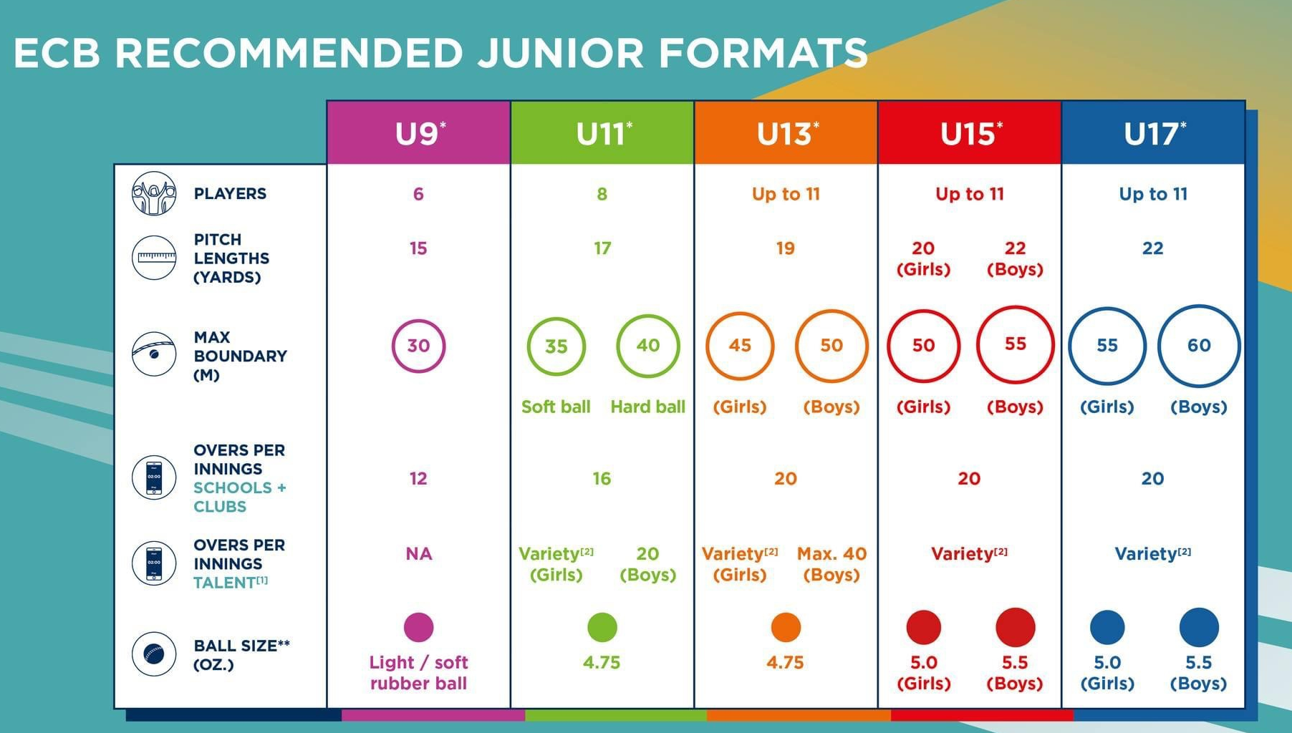
Formats for even years play up one year. e.g. format for U12 is that for U13s
For more detail see ECB junior formats
Equipment:
In hard ball cricket, the following must be worn when batting:
- pads
- a helmet (with face guard and conforming to BS 7928: 2013)
- gloves
- and a protector (box) for boys.
- Wicket keepers must wear a helmet (with face guard), box, pads and gloves even if standing back.
Thigh, arm and chest guards may also be worn. The above equipment is not mandatory in soft ball cricket but the manager should always consider a child’s safety with regard to equipment.
When a junior goes to bat, either in a match or in the nets, the manager should always ask the player if they are wearing a box.
Fielding restrictions for juniors
Unless standing back on the offside behind the wicket:
- Any player fielding close to the wicket should wear a helmet and protective box;
- u16 and u18 who has not reached 18 years of age, must wear a helmet and box if up to 6
yds from the bat
- up to u13 must be no closer than 11 yds from the bat
- There are further fielding restrictions mandated in some competitions

Bowling restrictions
Some points to consider:
- All players are encouraged to look after their fitness, warm downs are particularly important
- Re-engineering bowling actions can be difficult and dangerous. If you believe this is needed, a second opinion of a senior coach is recommended to consider a remedial programme.
- Please consult HJC should you suspect that a player needs help with life-style e.g. diet
- Coaches should consider the fitness and action of all bowlers, including slow bowlers, recognising that many young bowlers change their bowling actions when they have growth spurts.

The following are fast bowling directives. (Fast bowling is defined as any deliveries for which wicketkeepers of his/her peer group would normally stand back.

Practice sessions
Age Max balls per session Max sessions per week
Up to u/13 30 balls 2 sessions
u/14 u/15 36 balls 2 sessions
u/16 u/17 36 balls 3 sessions
u/18 u/19 42 balls 3 sessions

More detail can be found here. For guidance it is recommended that in any seven day period a fast bowler should not bowl more than four days and for a maximum of two days in a row.

Young fast bowlers should be aware of these requirements, which apply to both club, county any other representative match/session.

Safeguarding and Risk Management
Team managers should familiarise themselves with the club’s Welfare Policy and the links in it to the ECB Safe Hands and The Safeguarding Kit Bag

The Essex County website www.essexcricket.org.uk), also provides a link to safeguarding including social media.

The County website will show details of any accredited ECB coaching courses which club coaches and team managers are encouraged to attend when they become available, in addition to our club’s ongoing training sessions.

Coaches must have in addition to an ECB recognised cricket coaching qualification, a current DBS clearance, and valid first aid and safeguarding training and. Please note, these require renewal, normally every three years.

The following welfare issues are highlighted:
- Please always do a visual risk assessment of your coaching/ match environment. A detailed report is not required UNLESS there are issues that must be addressed.
- Be aware of any allergies or conditions (e.g. asthma) that players have and check that they have their medication.
- If a player is hurt or there is another incident:
  - make a note, including any action taken, preferably on your mobile notebook and inform the head of safeguarding, Niru Williams, niru.wansteadcc@outlook.com
  - Parents should always be informed and if the injury or illness is potentially serious, also inform The HJC and follow up with a phone call(s) to the parents to monitor progress.
  - Safeguarding issues of concern must be reported to a member of the welfare team. Club policy encourages members/ parents to report concerns.

The Club’s Junior Players’ Development
Our juniors are our future, and our commitment is to engage them in stimulating club activities as they progress their careers. We have an active Junior Volunteer Accreditation Scheme (our ‘Junior Volunteers’) who are offered worthwhile life experiences in addition to our well established coaching and Duke of Edinburgh achievement awards. The age of thirteen is a good time to become a Junior Volunteer, it is also the developmental stage when juniors can be considered to play adult cricket.

Thank you
Our team managers, coaches and adult captains are important club ambassadors. Thank you for the considerable support you provide, it makes a positive difference to our club community.

